** **ATAR Chemistry – Unit 1 & 2**

**Practical Validation Quiz**

Name: Total Score: /36

**Exp. 22 – Solubility Rules**

1. Fill in the following table with the colour of the precipitate, write “NR” if there is no precipitate formed and the colour of the solution (if no colour write clear) , if there is when each combination of solutions is mixed together. [6]

|  |  |  |  |  |
| --- | --- | --- | --- | --- |
| Solutions | NaNO3 | NaCl | Na2SO4 | Na2CO3 |
| CuSO4 | NR\Blue soln | NR/blue soln | NR/blue soln | Green ppt |
| Pb(NO3)2 | NR/clear | White ppt  NR at low concn | White ppt | White ppt |
| BaCl2 | NR | NR | White ppt | White ppt |

**Experiment 26- pH of Materials Around the House and common acids and bases**

2. Identify the following as either ***acidic****,* ***basic*** *or* ***neutral*** when in solution: [2]

* 1. Lemon juice Acidic
  2. Household ammonia Basic
  3. Sugar Neutral
  4. milk acidic

3. Consider the 1 M solutions of H2SO4, HCl, NaOH, CH3COOH, NH3. Place each chemical in the table below. [3]

|  |  |  |
| --- | --- | --- |
| pH > 7 | pH = 7 | pH < 7 |
|  |  | H2SO4 |
| NaOH |  | HCl |
|  |  | CH3COOH |
| NH3 |  |  |
|  |  |  |

4. Describe and fully explain any physical or chemical test that could be used to place the unknown solutions in the three groups [3]

pH meter – measures the concentration of hydrogen ions (1)

The concentration of hydrogen ions will be greater than 1x 10-7mol L-1 for an acid giving pH <7 (1)

The concentration of hydrogen ions will be less than 1x 10-7mol L-1 for a base giving pH> 7 (1)

**Experiment 29- Electrical Conductivity of Acids and Bases**

5. a) In Expt 29 you measured the current between two electrodes. Explain how solutions of acids and bases conduct an electric current. [2]

*In solutions of both acids and bases, free ions are present (1)*

*The ions in solution are charge carriers allowing electrical current to be conducted (1)*

6. Explain how the variables of ‘strong’ vs ‘weak’ and ‘concentrated’ vs ‘dilute’ affect the conductivity of an acid. [4]

*The conductivity of a solution is increased with the concentration of the ions in solution (1).*

*Strong acids (and bases) fully ionise, while weak acids (and bases) do not (1).*

***At the same concentration*** *strong acids have a higher concentration of ions than weak acids (1)*

*Concentrated acid (or bases) have a higher concentration of ions compared to dilute solutions. (1)*

*Conductivity is related to concentration of ions, how do the above variable affect concentration?*

7. Give an example of each of the following : [2]

Strong acid : *HCl or H2SO4* Weak acid: *CH3COOH* Weak base : *NH3* Strong base : *NaOH*

8. Name 2 safety precautions you had to take with this experiment [2]

*Don’t touch the electrodes*

*Wear safety glasses*

**Exp. 31/32 – Acid reactions with some metal compounds and metals**

9. Write ionic equations for the reactions between each of the following: [5]

* + 1. hydrochloric acid and a solution of sodium hydroxide

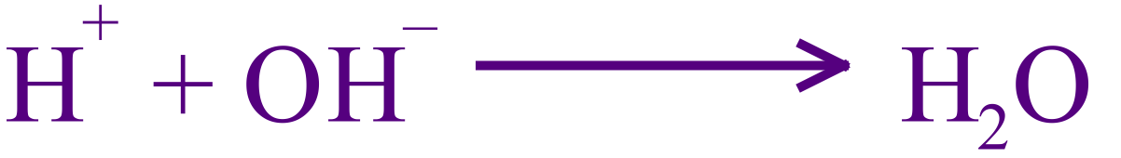

* + 1. hydrochloric acid and powdered copper (II) oxide



* + 1. hydrochloric acid and solid calcium carbonate



* + 1. sulphuric acid and a solution sodium hydrogen carbonate



* + - * 1. Write an ionic equation for the reaction between any reactive metal and hydrochloric acid.

*For example: (preferable to use Mg or Zn)*



10. [ 3 marks]

a) How would you test for CO2? __*bubble the gas through limewater__(1)_________________________________*

b) How would you test for H2 (g)  ______ *pop test (1)*___________________________________________

c) Write the chemical reaction involved for the test in (b)?  *H2(g)+O2(g) → H2O(g) (1)*

11. 20ml of an unknown concentration of hydrochloric acid fully reacted with 0.513g of calcium carbonate (Q9, equation iii). Calculate the concentration and pH of the HCl, assuming all of the hydrochloric acid reacts. [4 marks]



n (CaCO3) = m /M = 0.513/ (40.08+ 12.01+3x16) =0.0051254g (1)

n (H+) = 2 x n (CaCO3) = 0.01025 mol (1)

[H+] = c(H+) = n(H+)/ V = 0.01025/ 0.020

[H+] = 0.51254 mol L-1 (1)

pH = -log [H+] = -log (0.51254) = 0.290 (1)

End of Quiz